# What is Data Storytelling?

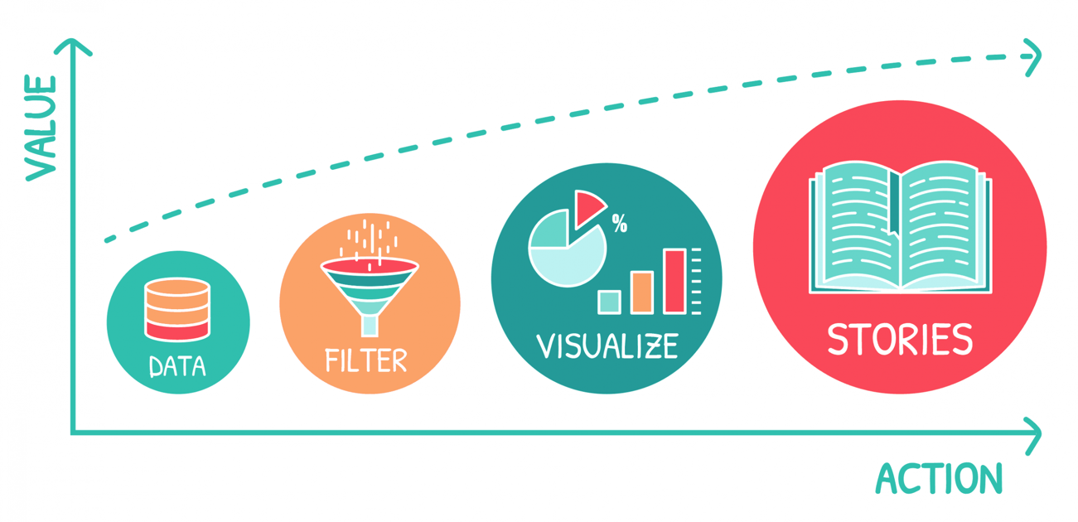

14 April 2020

Source: <https://www.datatelling.eu/what-is-data-storytelling/>

What is Data Storytelling?

As we know, data is rather indigestible, sometimes intimidating, sometimes even obscure, and although companies are investing more and more in data-driven approaches, it is a fact that too few employees use data as a work tool in its own right. The reason? The reason is that interfaces such as spreadsheets or dashboards are too complex and make access to data too restrictive. The recent arrival of Data Storytelling brings a new breath to the data access market and tends to democratize its use in organizations and beyond.

**Let’s define Data Storytelling**

Data Storytelling is the principle of telling stories based on data. Stories that speak to the target users and are therefore personalised and contextualised.

Is there a difference between Dataviz and Data Storytelling?

Dataviz is the art of making numbers [speak visually through graphs](https://www.datatelling.eu/data-storytelling-how-to-communicate-visually-and-effectively-2/) of types, curves, bars, donuts, cartography …, where Excel tables fail. It is a formatting of the numerical information to make it easier to understand. However, it focuses on this visual production of data without integrating the narrative dimension.

Data Storytelling is an extension of Dataviz, itself a product of Business Intelligence. The big difference comes from this desire to facilitate the understanding of analyses by applying communication methods based on a narrative structure of the discourse close to that of stories.

This relatively recent concept is acclaimed by [Gartner](https://www-lemagit-fr.cdn.ampproject.org/c/s/www.lemagit.fr/conseil/Le-Dynamic-Data-Storytelling-au-cur-de-la-nouvelle-generation-de-BI-Gartner?amp=1) as one of the main directions of Business Intelligence in the coming years.

Data Storytelling is considered the best opportunity to accelerate the democratization of data usage in organizations because it simplifies access to data. Data would no longer be reserved only for seasoned profiles, but would also be accessible to novices. This is what we consider should be the goal of a Data Driven approach.

**The main principles of Data Storytelling**

**Switch to playback mode:**

The first principle that should apply to Data Storytelling is ease of access and use of the interface.

It must be as simple as possible, focused on consulting the data, limiting interaction with it as much as possible, forgetting tabbed browsing and reducing the effort of handling it to its strict minimum. For this reason, dashboard type solutions are not suitable for data storytelling.

In this context, the simplest mode is to provide all the analyses on the same page, limiting navigation to the mouse scroll to go down or up the analysis page.

Users are in a “read” mode as if they were opening a book and could browse through all the analyses on the same page.

**The ultra customization:**

Data Storytelling must serve the interests of the business and target users, it must best reflect the business specificities in its analyses and their organizations. This is why it must be put in the hands of the business in the creation and adaptation of stories. It is absolutely necessary to convey business intelligence to data storytelling because it is the starting point for the narrative orientation of the analyses. When a business manager of a story designs the analyses, he does it with his business expertise: What information should be shown first? What other analyses should I associate them with? How should I structure the analyses? The Business Manager will organize the story by topics, themes, related to the specificity of the business, so that the target users will evolve in a familiar and highly relevant framework.

**Comment, comment, comment:**

Storytelling also relies on the ability to tell and explain data, so it will be important to associate comment spaces managed by the business manager to the story. This will allow, for example, to introduce an analysis theme and to explain its orientation in order to guide users in their journey, or to explain the nature of a graph and how to read it, especially when using less common graphs such as Sankey Diagrams or Dependency Wheels …. Or to comment on a graph result by explaining the trends observed.

The important thing is to facilitate the user experience by guiding them through each step of their consultation.

**All actors of Data Storytelling :**

Data Storytelling must be a place for exchange and understanding, so it must allow the user group to share and comment on the analyses. Can we explain a particular analysis result within the group? Are there elements of understanding to be associated to a graph so that all users have a better understanding? Users become actors of Data Storytelling.

**Open format :**

Data Storytelling should not be an isolated and disconnected application, on the contrary, it should be open and allow to interact in a very operational way with business needs.

It will also be relevant to associate business elements that will reinforce the understanding or support a message. For example, we could refer to a previous study and integrate it in order to be able to consult it, or put a document detailing good practices related to the business, or even descriptive sheets of products or action campaigns… The story is thus intended to be very operational, close to its users.

**In a nutshell**

Data Storytelling is positioned as a more accessible, fun and operational form of Dataviz or other Business Intelligence solutions. It bodes well for the future of access to Data and should allow a real democratization within organisations.